SYNOPSIS

ON

“Chronic Kidney Disease Status Prediction”

Submitted in

Partial Fulfillment of requirements for the Award of Degree

*of*

Bachelor of Technology

*In*

Computer Science and Engineering

By

**(Project Id: 22_CS_3A_18)**

# Mohd Aamir (2001640100159)

# Sudhir Kumar (2001640100267)

# Neelesh Kumar Yadav (2001640100174)

Under the supervision of

**Mr. Arun Kumar Pandey**

**(Assistant Professor)**



**Pranveer Singh Institute of Technology**.

 Kanpur - Agra - Delhi National Highway - 19

Bhauti -Kanpur - 209305.

(Affiliated to Dr. A.P.J. Abdul Kalam Technical University)

1. Introduction

The disability of the kidneys to perform their regular blood filtering function and others is called Chronic Kidney Disease (CKD). The term “chronic” describes the slow degradation of the kidney cells over a long period of time. This disease is a major kidney failure where the kidney sans blood filtering process and there is a heavy fluid buildup in the body. This leads to alarming increase of potasium and calcium salts in the body. Existence of high levels of these salts result in various other ailments in the body. The prime job of kidneys is to filter extra water and wastes from blood. The efficient functioning of this process is important to balance the salts and minerals present in our body. The righ balance of salts are necessary to control blood pressure, activate hormones, build red blood cells, etc. A high concentration of calcium leads to various bone diseases and cystic ovaries in women. CKD also may lead to sudden illness or alergy to certain medicines. This state is called as Acute Kidney Injury(AKI). An increased blood pressure may lead to heart problems and heart attacks. CKD in many cases leads to permenent dialysis or kidney transplants. A history of kidney disease in the family also leads to high probability of CKD. Literature shows that almost one out of three people diagnosed with diabetes have CKD. Literature also presents evidences of early identification and care of CKD can improve the quality of the patients life. Prediction algorithms in machine learning can be intelligently used to predict the occurence of CKD and presents a method of early medication. The detailed review on literature shows the application of various machine learning algorithms to predict CKD. This paper tries to predict CKD using the classifiers like Decision Tree,Random Forest and Support Vector Machine and also suggested best prediction model

2. Project Objective

The objective of this Project is to perform a comparative analysis of the prediction of kidney disease using intelligent ML methods. Diagnosis of kidney impairment early may help in rectification, which is not always possible. To avoid serious damage, we will need to get a better understanding of a few indicators caused by kidney disease. The main motivation of this Project is to predict the chronic disease by analyzing data from those indices and applying three machine learning classification approaches to predict the disease, then choosing the approach with the highest accuracy rate.

This should give a clear picture of the project. Objectives should

be clearly specified. What the project ends up to and in what way

this is going to help the end user has to be mentioned.

1. Feasibility Study:

**Start Date: 05-sep-2022 End Date: 30-Nov-2022.**

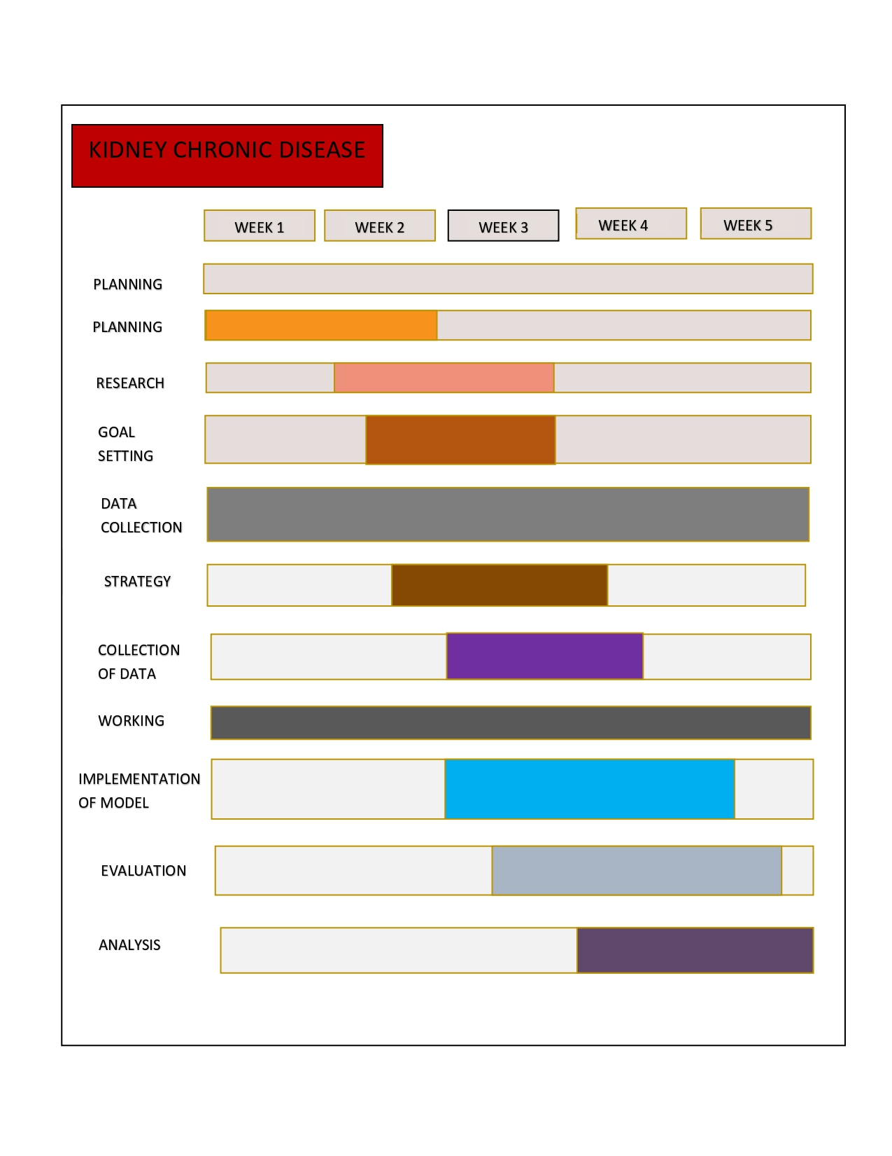

1. Methodology/ Planning of work

The block diagram of the proposed system. The framework utilizes the Chronic Kidney Disease (CKD) prediction dataset. After preprocessing and feature selection, the DT, KNN, and logistic regression algorithms have been used.

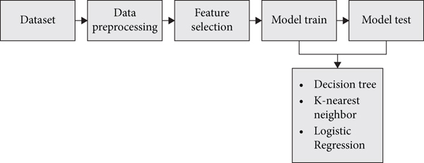

5. Tools/Technology Used:

5.1 Hardware Requirements

* + Processor: Minimum Pentium i3 Processor
  + Hard Disk: 500GB
  + Ram : 2 GB

5.2 Software Requirements

* + Jupyter Notebook
  + Operating System: Windows 10
  + TenserFlow
  + GitHub

6. References: [IEEE format]:

* Udemy

<https://www.researchgate.net/publication/344319206_Chronic_Kidney_Disease_Prediction_Using_Machine_Learning_Methods>